**Name: Sreelakshmi M Nair**

**Roll No: 40**

**Batch: B**

**Date: 12/05/2022**

**NETWORKING & SYSTEM ADMINISTRATION LAB**

**Experiment No.: 16**

**Aim**

write shell script to find sum of all digits in a number.

**Program**

#!/bin/bash

echo "Enter a number"

read num

s=0

while [ $num -gt 0 ]

do

mod=$((num % 10))

s=$((s +mod))

num=$((num / 10))

done

echo $s

**Output:**

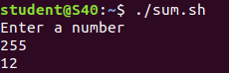

**Experiment No.: 17**

**Aim**

write shell script to find the average of number of numbers entered in a given line.

**Program**

#!/bin/bash

echo "Enter size"

read size

i=1

s=0

echo "Enter Numbers"

while [ $i -le $size ]

do

read num

s=$((s+num))

i=$((i+1))

done

avg=$(echo $s / $size | bc -l)

echo $avg

**Output:**

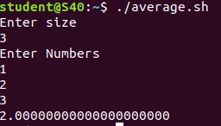

**Experiment No.: 18**

**Aim**

write shell script to find addition using switch case.

**Program**

#!/bin/bash

echo "Enter two numbers"

read a

read b

echo "Enter choice :"

echo "1. addition"

echo "2.Substraction"

echo "3.Multipilcation"

echo "4.Division"

read ch

case $ch in

1)res=`echo $a + $b | bc`

;;

2)res=`echo $a - $b | bc`

;;

3)res=`echo $a \* $b | bc`

;;

4)res=`echo "scale=2; $a / $b" | bc`

;;

esac

echo "Result : $res"

**Output:**



